08/08
- Is this picture an IB core topic or option topic? Which topic?

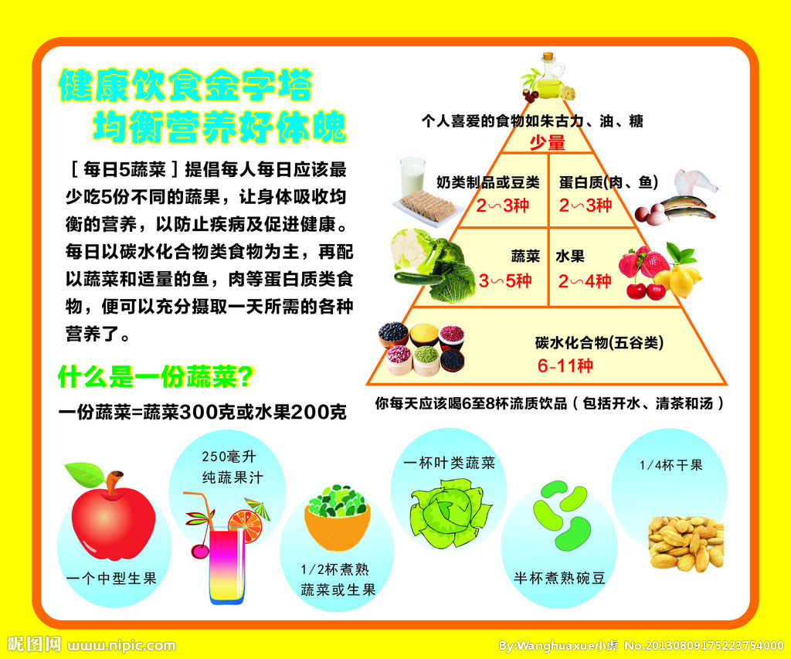
2. Your homework today is to describe the pyramid in Chinese and memorize it, NO notes will be allowed. You will have a quiz grade on 08/10.

3. IB Juniors:
- Be familiar with ALL the words in Lesson 13 & 14 (轻松学中文4).
- You MUST memorize (to read, to write, to understand, to say) the following words:

区 周围 环境清静 风景优美 城里 郊外 许多
花草树木 空气 清新 交通便利convenient transportation 一年四季
- Ms. Feng will go over the following phrases/sentences:
就：(汉语1000常用字P210) 我家就在学校对面。
…不太…: 我不太高。/我不太喜欢米饭。
…挺… : 他挺好的！
…真希望…： 我真希望我有很多钱。
…,这样…: 我真希望我有很多钱，这样我就可以买一个新电脑了。
- Workbook (轻松学中文4) P153/25&26 P157/9
Homework:
No 2.
Add 5 words that you learned today (lesson 13 & lesson 14) on each side.
住在城里： 住在郊区：
08/08
- Is this picture an IB core topic or option topic? Which topic?

2. Your homework today is to describe the pyramid in Chinese and memorize it, NO notes will be allowed. You will have a quiz grade on 08/10.

4. IB Seniors:
Ms. Feng will go over the Paper 1 question types. You will need to memorize the key words today.
Homework:
No.2
Study the question words.

