- QUIZLET-天气 (Only the TEST portion)
This is the link to add my class: https://quizlet.com/join/W3p8wURgV

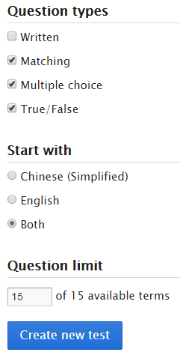

- Translate and pronounce the dialog.
Use dictionary (on the bookshelf) as the reference.
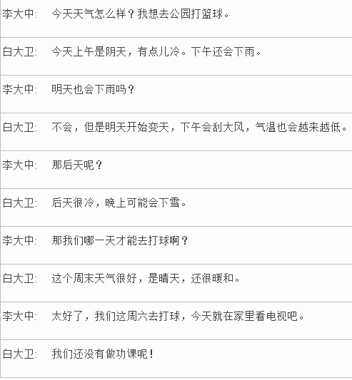

- Group activity. (get ready to present on 08/09 in class)

