08/04
- 准10分钟描述图片, 08/08 上课抽查3个人。(抽签决定)
Describe this picture. You have 10 minutes to prepare. 08/08 3 people will be randomly called to describe as DO NOW.
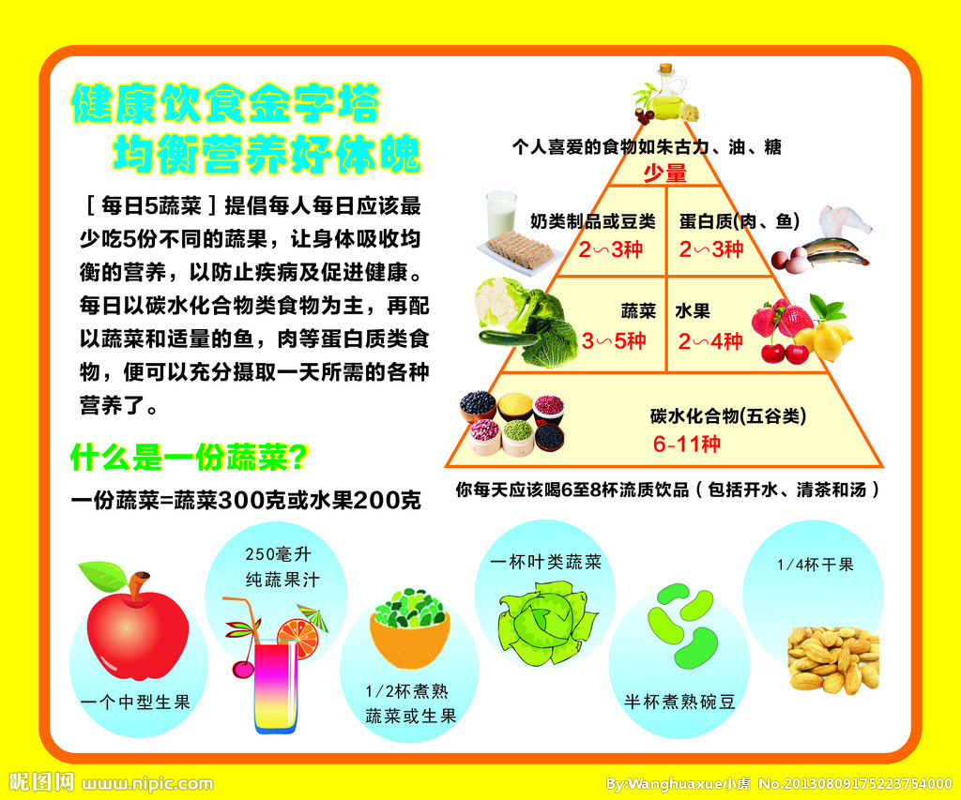
- Go over syllabus & IB guide
- Assessment outline-SL
- Core & options
- Organize your notes in your binder. (Mark down the date, IB general)

- QUIZLET – core & 5 options
- Add to the new class
- Will take a vocab QUIZ on 08/08
- HOMEWORK
Finish your summer work and turn it in on 08/08
Prepare for the picture & QUIZLET quiz (core & 5 options)

